**Building on 10 years of the Fundamental Rights Charter**

Rights areas:

* [EU Charter of Fundamental Rights](https://fra.europa.eu/en/taxonomy/term/990)
* [Support for human rights systems and defenders](https://fra.europa.eu/en/taxonomy/term/989)

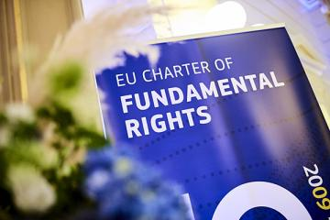

Ten years ago on 1 December, the full force of the EU’s Fundamental Rights Charter came into play. This landmark bill of rights for the EU has the power to make a difference. One decade on, it is yet to reach its full potential. This is changing, slowly but surely.

**Publication**

[**The EU Charter of Fundamental Rights - Use and added value in EU Member States**](https://fra.europa.eu/node/36311)

Within the scope of EU law, the Charter is legally binding across all EU Member States. It applies in courts and government must respect it.

Since coming into force on 1 December 2009, the Charter has been driving a more coherent and comprehensive application of fundamental rights.

EU bodies work hard to ensure their laws and policies comply with the Charter.

In the EU Member States, the judiciary and policymakers are gradually making greater use of the Charter but their uncertainty about how and when it applies remains a challenge that needs addressing.

FRA’s [handbook for legal practitioners](https://fra.europa.eu/en/publication/2018/national-guidance-application-eu-charter) and online [Charterpedia](https://fra.europa.eu/en/charterpedia) tool explaining the Charter simply can help. As can its series of country factsheets on the [use and added value of the Charter](https://fra.europa.eu/en/publication/2019/eu-charter-fundamental-rights-use-and-added-value-eu-member-states) for each and every Member State.

Soon, FRA will also release its [EU Fundamental Rights Information System](https://fra.europa.eu/en/project/2018/eu-fundamental-rights-information-system). It will pull together judicial findings from all bodies dealing with fundamental rights, country by country, theme by theme. It should prove to an invaluable reference point for anyone dealing with rights.

With a new European Commission about to start, promising a revised Charter strategy, momentum is building towards improving awareness and use of the Charter nationally.

This will galvanise efforts to making fundamental rights a reality for all. This will help ensure people across the EU can fully benefit from the Charter and all that it can offer.

Let’s continue building on the Charter in the courts, in the parliaments, in the legal colleges and on the streets across the EU.

This will allow the Charter make the difference that it was intended to when it came into force 10 years ago.